## **LOAD TEST ON DC SHUNT MOTOR**

#### **AIM:**

To conduct load test on DC shunt motor and to obtain performance curve.

#### **APPARATUS REQUIRED:**

| **S.NO.** | **Apparatus** | **Range** | **Type** | **Quantity** |
| --- | --- | --- | --- | --- |
| 1. | Ammeter | (0-20)A | MC | 1 |
| 2. | Voltmeter | (0-300)V | MC | 1 |
| 3. | Rheostat | 1050Ω / 1A | Wire wound | 1 |
| 4. | Tachometer | (0-1500)rpm | Digital | 1 |
| 5. | Connecting Wires | - | - | As required |

#### 

#### **FORMULA:**

Torque, (τ) = 9.81 x R x (S1 ∼ S2) N-m

Input Power= VLIL Watts

Output Power = 2π Nτ / 60 watts

Percentage Efficiency, (η) = Output Power / Input Power x 100 %

where

S1, S2 - Spring balance reading in Kilogram

VL - Line voltage (volts)

IL - Line current (A)

N - Speed (rpm)

R - Radius of the brake drum (m)

#### **CIRCUIT DIAGRAM:**

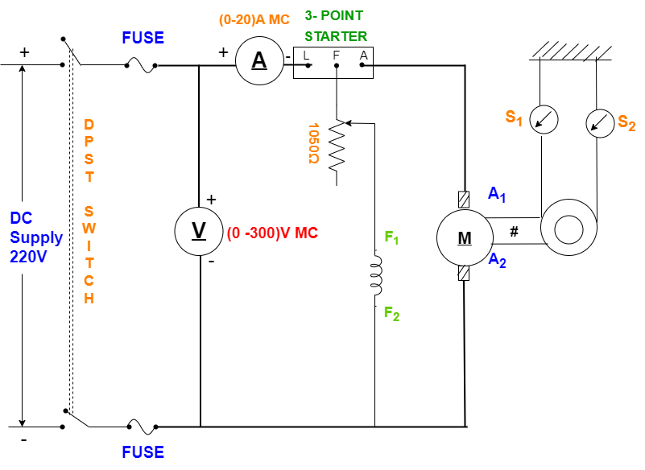

**NAMEPLATE DETAILS OF DC MOTOR:**

Fuse rating: % of full load current

Voltage: V

Ampere: A

Speed: rpm

#### **THEORY:**

The Shunt motor has definite no load speed hence it does not run away when the load is suddenly thrown off provided the field current remains closed. The drop in rate from no load to full load is small hence this motor is usually referred to as a constant-speed motor.

The efficiency curve is usually of the same shape for all-electric motors and generators as the shape of the efficiency curve and the point of maximum efficiency can be varied considerably by the designer, though it is advantageous to have an efficiency curve that is relatively flat so that there is little change in efficiency between load and 25% overload and to have the maximum efficiency as near to the full load as possible.

From the Curve, it is observed that a certain Value of current is required when output is zero. The motor input under no- Load conditions goes to meet the various losses, occurring within the machines.

#### **PROCEDURE:**

1. The connections are made as per the circuit diagram.
2. The DPST switch is closed and the 3-point starter handle is moved smoothly from the OFF to the ON position.
3. The motor is started and the machine is brought to rated speed by adjusting the field rheostat.
4. After that, the rheostat is kept in a fixed position, and no-load voltage, no load current, and no load speed are noted.
5. By using the brake drum with the spring balance arrangement the motor is loaded and the corresponding readings are noted up to the rated current.
6. After the observation of all the readings, the load is released gradually and the field rheostat is brought to the minimum position.
7. Using the DPST switch, a motor is switched OFF at no load condition.

**CALCULATION OF FUSE RATING:**

Fuse current rating = Rated current x 1.25 = Å

#### **TABULAR COLUMN:**

| **S.NO.** | **Input Voltage**  **(VL)** | **Input Current**  **(IL)** | **Motor Speed**  **(N)** | **Spring Balance Reading** | | **Torque**  **(T)** | **Input power**  **(VL IL)** | **Output power**  **(2πNτ/60)** | **Efficiency (η)**  **(%)** |
| --- | --- | --- | --- | --- | --- | --- | --- | --- | --- |
| **S1 (Kg)** | **S2 (Kg)** |
| 1. |  |  |  |  |  |  |  |  |  |
| 2. |  |  |  |  |  |  |  |  |  |
| 3. |  |  |  |  |  |  |  |  |  |
| 4. |  |  |  |  |  |  |  |  |  |
| 5. |  |  |  |  |  |  |  |  |  |
| 6. |  |  |  |  |  |  |  |  |  |

#### **MODEL GRAPH:**

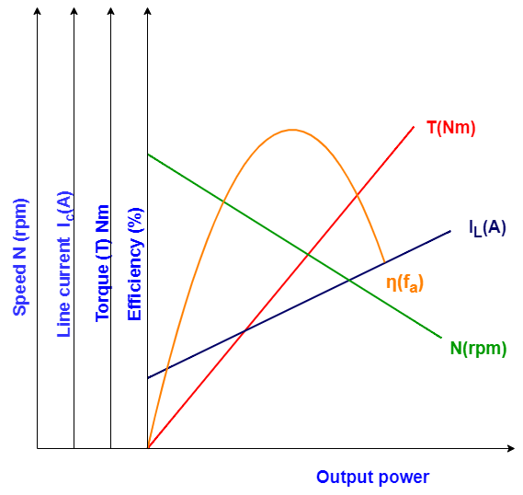

**PRECAUTIONS:**

1. The DPST switch must be kept in an open position.
2. Make sure that the starter handle is in the OFF position.
3. Rheostat must be kept in a minimum resistive position.
4. There should not be any load on the motor while starting.
5. While running on load, the Brake drum is cooled by pouring water inside the brake drum.